FRUITS – OWOCE

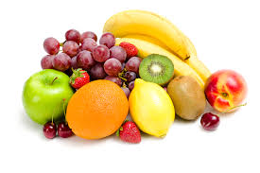

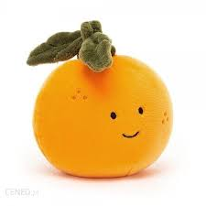” FRUIT NAMES ” -Nazwy owoców

https://www.youtube.com/watch?v=9VjqnaFSn9Y&t=1s

” FIVE LITTLE FRUITS ”- Piosenka o owocach

https://www.youtube.com/watch?v=lJvT9CbIXRc

” PEPPA PIG LOVES FRUITS ”- Bajka o owocach
https://www.youtube.com/watch?v=u5b6MkcCyM8

